The first draft submission guidelines
1.Log in to the IEIS2019 International Academic Conference Paper submission system and register.
The login URL is: http://zy02.bjtu.edu.cn:8080/BaseFrame/?conf=11
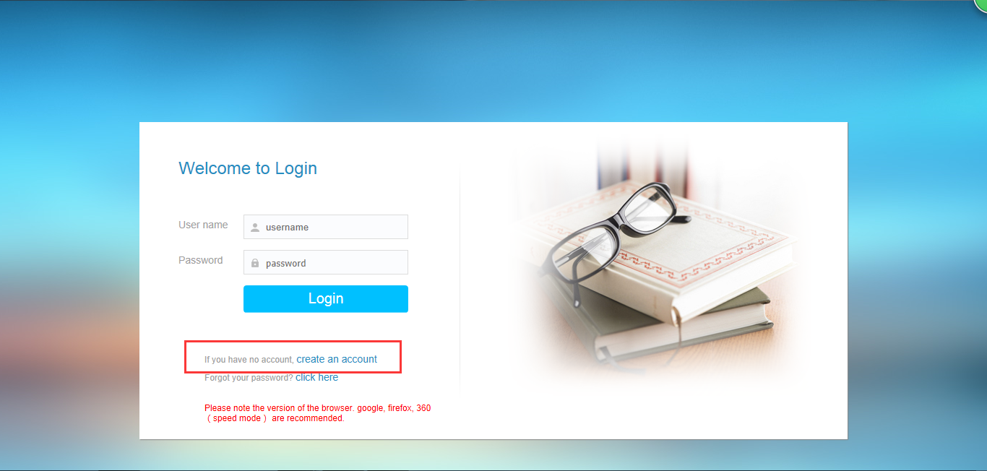

Fill the basic information , click “Submit” and log in again.
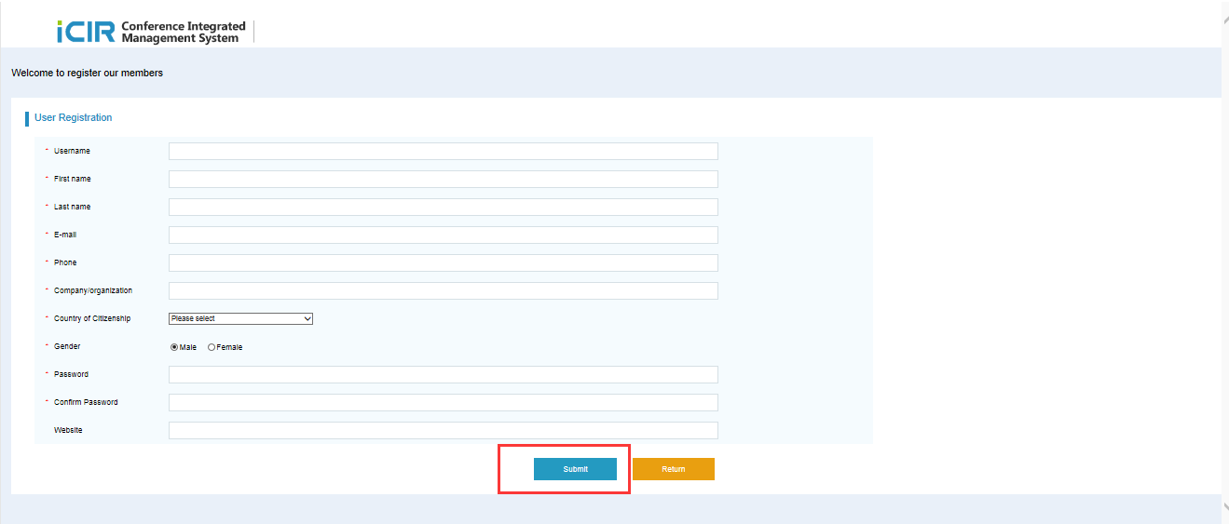

2.Enter the system, select the "My Papers" page and click "Paper Submission" to submit the paper.
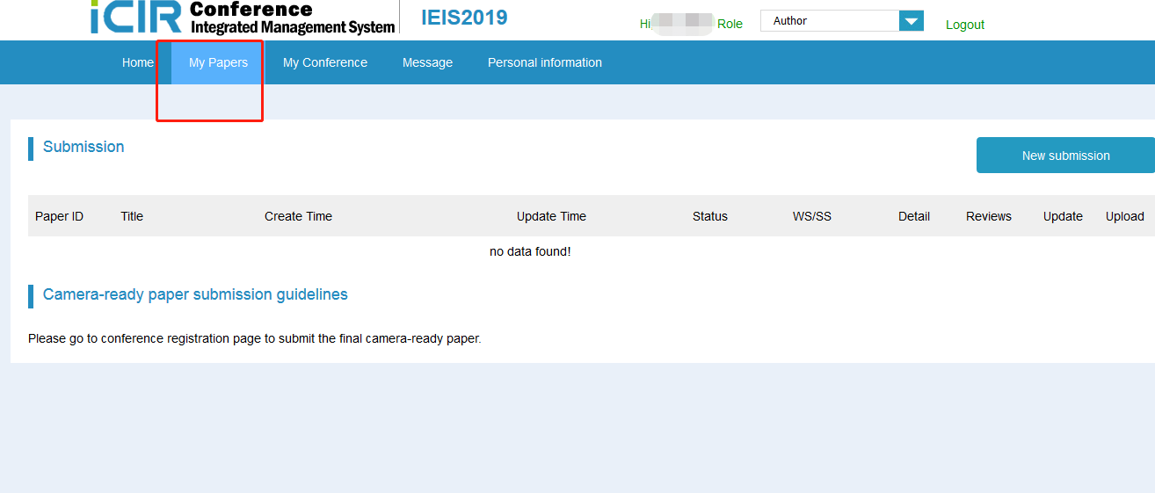
3. The paper submission page is as follows, you need to fill the authors, title, abstract, study area and other information, and upload the first draft of the paper, and finally click "Submit" to submit.
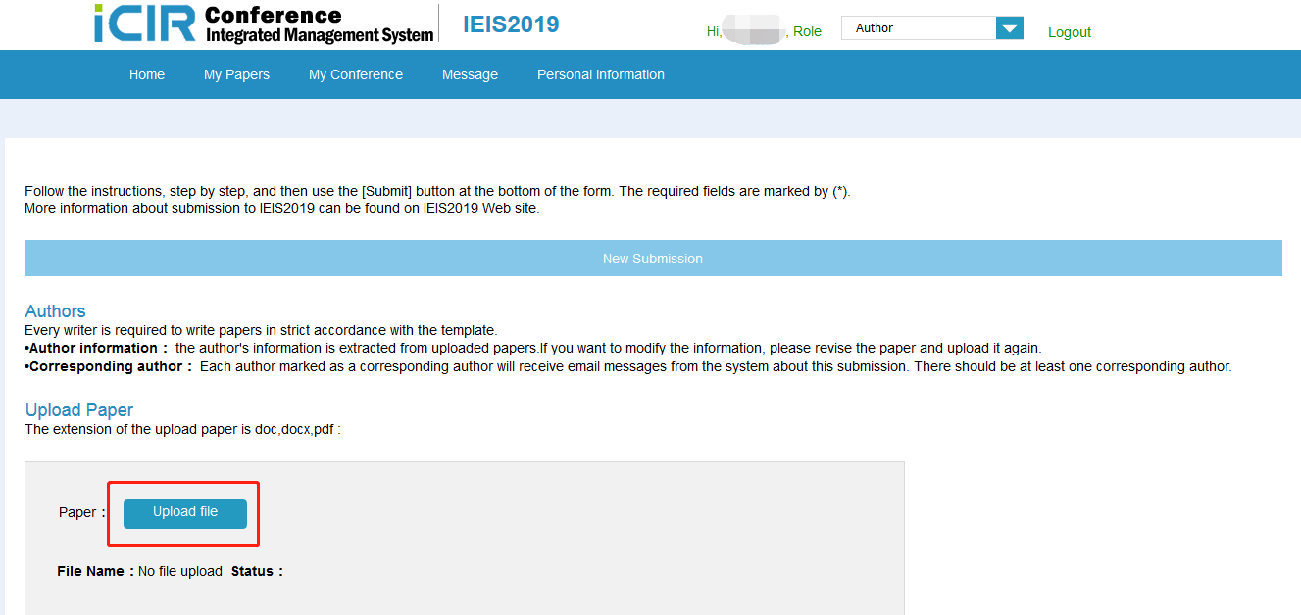
if the format of the paper is correct, the information of the author, title, abstract, keywords, etc. will be automatically recognized, and you do not need to input it yourself.
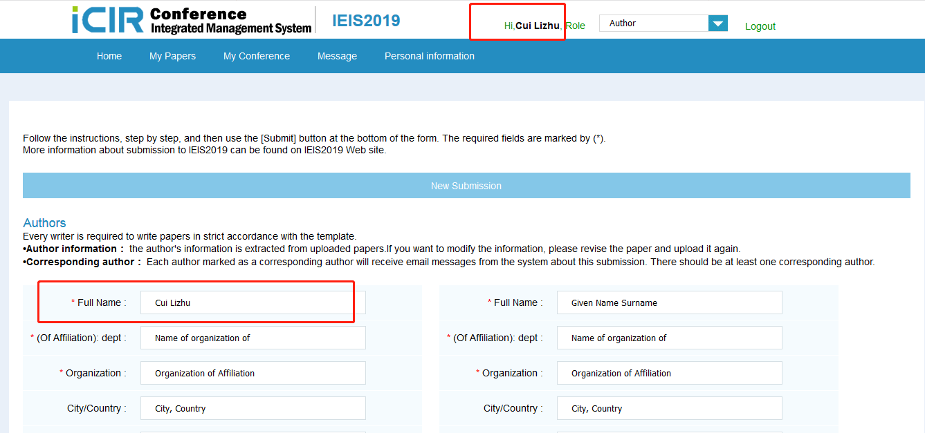
Things to note:
(1) At least one of the authors should be corresponding author.
(2) It’s support for paper formats in pdf/doc/tex/docx.
(3)After you upload your paper, according to the "Status" to check whether the papers has uploaded successfully.

4. After your paper was submitted, re-enter the "My Papers" page, as shown in the following picture that your paper has been successfully submitted.
